ĐẠI HỌC KINH TẾ TP. HỒ CHÍ MINH

TRƯỜNG CÔNG NGHỆ VÀ THIẾT KẾ
KHOA CÔNG NGHỆ THÔNG TIN KINH DOANH


MÔN HỌC: PHÂN TÍCH DỮ LIỆU MẠNG XÃ HỘI
ĐỀ TÀI: PREDICTING NEGATIVE LINKS BETWEEN REDDIT COMMUNITIES USING TEMPORAL SIGNED-NETWORK FEATURES

Giảng viên hướng dẫn | TS. Nguyễn Thành Huy
Mã lớp học phần | 26D1INF50916501
Khóa | 49
Trần Viết Gia Huy |  | 31231027056
Nguyễn Minh Nhựt |  | 31231022656
Nguyễn Trọng Hưởng |  | 31231023691
Tô Xuân Đông |  | 31231025345

Thành phố Hồ Chí Minh, ngày 10 tháng 06 năm 2026
TABLE OF CONTENTS
ABSTRACT 4
CHAPTER 1. INTRODUCTION 5
1.1. Research Background 5
1.2. Research Problem 5
1.3. Research Objectives 6
1.4. Research Questions 6
1.5. Contributions of the Study 7
CHAPTER 2. THEORETICAL BACKGROUND AND LITERATURE REVIEW 8
2.1. Theoretical Background 8
2.2. Social Network Data Analysis and Reddit 9
2.3. Signed Networks and Structural Balance Theory 10
2.4. Link Prediction in Social Networks 10
2.5. Centrality Features and Community Structure 11
2.6. Reddit Hyperlink Network and Related Studies 11
2.7. Research Gap and Study Positioning 12
CHAPTER 3. PROBLEM FORMULATION AND DATA 14
3.1. Problem Formulation 14
3.2. Data Provenance and Suitability 14
3.3. Data Description 15
3.3.1. Raw Data Files 15
3.3.2. Data Schema 15
3.3.3. Label Semantics and Text-Derived Features 15
3.4. Data Quality Audit 16
3.5. Data Preprocessing 17
3.6. Exploratory Data Analysis 17
CHAPTER 4. RESEARCH METHODOLOGY 21
4.1. Temporal Signed-Network Representation 21
4.2. Temporal Anti-Leakage Design 21
4.3. Prediction-Label Construction 22
4.4. Pairwise Historical Features 22
4.5. Network Features 22
4.5.1. Degree and Signed-Degree Features 22
4.5.2. PageRank, Betweenness, and Reciprocity 23
4.5.3. Clustering and Neighborhood Structure 23
4.6. Community and Structural-Balance Features 23
4.7. Text-Derived Features 23
4.8. Models and Baselines 24
4.9. Ablation Study Design 25
4.10. Evaluation Metrics 26
4.11. Reproducibility 26
CHAPTER 5. EXPERIMENTS AND RESULT EVALUATION 27
5.1. Experimental Setup 27
5.2. Main Model Results 27
5.2.1. Best Model by PR-AUC 27
5.2.2. Baseline Comparison 28
5.2.3. Interpretation under Class Imbalance 29
5.3. Baseline and Ablation Analysis 30
5.4. Threshold, Precision, and Recall Analysis 30
5.5. K-Core Robustness Check 34
5.5.1. Robustness-Probe Design 34
5.5.2. Robustness Results 35
5.5.3. Limitations of the Robustness Probe 36
5.6. Error Analysis 36
5.6.1. True positives 36
5.6.2. False positives 37
5.6.3. False negatives 37
5.7. Model Interpretation 38
5.8. Network and Community Visualization 38
5.9. Discussion of Results 40
CHAPTER 6. CONCLUSION 42
6.1. Main Conclusions 42
6.2. Limitations and Threats to Validity 42
6.3. Future Directions 43
6.4. Recommendations for Interpretation 43
REFERENCES 44
APPENDICES 47

ABSTRACT
This study examines how predominantly negative relations among Reddit communities can be predicted from temporal signed-network evidence. Each subreddit is modeled as a node, and each hyperlink from a source subreddit to a target subreddit is represented as a directed signed edge. The dataset is obtained from the Kaggle Signed Graphs collection through the soc-RedditHyperlinks files, with scholarly provenance cross-checked against Stanford SNAP and Kumar, Hamilton, Leskovec, and Jurafsky's study of online community interaction and conflict. The prediction task is defined under a strict temporal anti-leakage protocol: feature construction uses only interactions observed before each cutoff, while labels are derived from a disjoint future window.
The pipeline integrates data auditing, preprocessing, signed-network construction, pairwise historical features, centrality measures, community-level indicators, structural-balance features, and text-derived attributes from the PROPERTIES vectors. The experiments compare dummy baselines, a historical negative-ratio heuristic, Logistic Regression, Random Forest, XGBoost, and LightGBM across history_only, text_only, graph_only, graph_no_balance, hybrid, and hybrid_no_balance feature sets. In the latest run, hybrid Logistic Regression obtains a test PR-AUC of 0.1840, ROC-AUC of 0.7569, and F1 score of 0.2700, outperforming prevalence-based baselines in a test setting where predominantly negative pairs account for only approximately 7% of observations. Additional threshold analysis, k-core robustness checks, error analysis, and assessment-criteria alignment indicate that historical interaction and signed-network structure provide the most stable predictive signals, while text-derived features are most useful when combined with graph features.
Keywords: Reddit Hyperlink Network, signed network, temporal link prediction, structural balance, social media data analysis.

CHAPTER 1. INTRODUCTION

1.1. Research Background
Modern social media platforms are not only spaces for individual information exchange; they also host online communities with distinct identities, norms, and collective interests. Reddit is a particularly suitable setting for this study because user activity is organized around subreddits, each of which can represent a topic, interest group, viewpoint, or discussion community. In this environment, inter-community interaction may occur through comments, mentions, citations, or hyperlinks to other subreddits.
Hyperlinks between subreddits may reflect information diffusion, cross-topic discussion, or the attention that one community directs toward another. However, such interactions are not uniformly positive. Some links may convey criticism, opposition, sarcasm, or other forms of negative stance. Analyzing signed hyperlink networks among Reddit communities is therefore directly aligned with social media data analysis, especially when the objective is to identify early analytical signals of negative inter-community relations.
In social network research, positive and negative ties are commonly represented as signed networks. This representation allows the analysis to capture not only whether two nodes are connected, but also the qualitative direction of their relationship. Balance theory and structural balance theory suggest that positive and negative ties can form meaningful structural configurations, particularly at the level of triads and community groups (Cartwright & Harary, 1956; Heider, 1946).

1.2. Research Problem
The central problem of this study is to estimate whether an ordered source-target subreddit pair will become negative-dominant within a future observation window. In this report, a pair is defined as negative-dominant when the number of future negative hyperlinks from the source to the target exceeds the number of future positive or neutral hyperlinks over the same window.
Importantly, this study does not treat a negative hyperlink as direct evidence of harassment, coordinated attacks, raids, or offline conflict. LINK_SENTIMENT is used as a proxy indicator of negative hyperlink-mediated interaction. This conservative interpretation keeps the empirical claims aligned with the dataset and prevents the model from being framed as an automatic conflict adjudication system.

1.3. Research Objectives
This study pursues four objectives. First, it represents Reddit hyperlink activity as a directed signed network of communities. Second, it constructs temporally valid feature sets that minimize future-information leakage during model development. Third, it compares baseline, graph-only, text-only, and hybrid models to quantify the contribution of each signal family. Fourth, it interprets the results through feature-importance analysis, threshold tradeoff analysis, k-core robustness checks, and local error-case inspection.

1.4. Research Questions
The study addresses four research questions:
- Which subreddits frequently act as sources or targets of negative links in the Reddit Hyperlink Network?
- Do signed-network features improve prediction compared with text-derived features alone?
- Does a hybrid model combining network, interaction-history, and text-derived features outperform simple baselines?
- Which features help explain predictions of predominantly negative future relations?

1.5. Contributions of the Study
This study makes five contributions. First, it documents data provenance by using Kaggle as the course-compliant access pathway while citing Stanford SNAP and Kumar et al. as the original academic sources. Second, it implements a temporal anti-leakage evaluation design in which all model features are computed from historical information only. Third, it systematically compares multiple models and feature groups through baseline and ablation experiments. Fourth, it strengthens the empirical analysis with k-core robustness checks, threshold analysis, and local error-case inspection. Fifth, it provides a reproducible project pipeline through an audit script, a staged runner, exported artifacts, and a minimal test suite.

CHAPTER 2. THEORETICAL BACKGROUND AND LITERATURE REVIEW

2.1. Theoretical Background
The theoretical foundation of this study begins with the representation of social media data as a graph. In this representation, each subreddit is modeled as a node, and each hyperlink from a source subreddit to a target subreddit is modeled as a directed edge. Because each edge is associated with a LINK_SENTIMENT label, the resulting structure can be treated as a directed signed network: positive or neutral links represent non-negative interaction, whereas negative links represent oppositional, critical, or otherwise negative stances. This graph-based representation transforms Reddit hyperlink data from isolated interaction records into a network object suitable for social media analysis.
The second theoretical foundation is signed-network theory and structural balance. Balance theory and structural balance theory argue that positive and negative relations among nodes can form balanced or unbalanced triadic patterns, thereby reflecting consistency or tension in relational structures (Heider, 1946; Cartwright & Harary, 1956). In online social networks, signed-network structure has also been shown to contain predictive signals for link signs (Leskovec et al., 2010). For this reason, this study includes common-neighbor patterns, triadic-balance features, and community-level negativity as part of its network-feature design.
Centrality measures provide a third theoretical foundation because they describe the roles of individual nodes in a network. Degree, in-degree, and out-degree capture direct connectivity; betweenness indicates whether a node lies on important paths between other parts of the network; and PageRank estimates node importance from the directed link structure (Freeman, 1978; Page et al., 1999). In the subreddit setting, these measures help distinguish communities that frequently generate links, communities that are frequently mentioned, and communities that occupy intermediary positions in interaction flows.
A further foundation is community detection. Community-detection algorithms, such as Louvain, identify groups of nodes with denser internal connectivity by optimizing modularity (Blondel et al., 2008; Fortunato, 2010). In this study, community detection supports not only visualization but also feature construction, including community negative ratio, same-community indicators, and community-pair negativity. These features capture the group-level context surrounding each source-target relation.
Finally, the prediction task is framed as temporal link prediction under class imbalance. Temporal networks require careful respect for chronological order because future graph structure should not influence past feature construction (Holme & Saramaki, 2012). This study therefore constructs features from historical windows and labels from future windows. Since negative-dominant relations are rare in the test set, PR-AUC is used as the primary metric because precision-recall evaluation is more informative than accuracy or ROC-only interpretation in imbalanced binary classification settings (Saito & Rehmsmeier, 2015).

2.2. Social Network Data Analysis and Reddit
Social network data analysis commonly focuses on how users, content, and communities interact in online environments. On Reddit, the community unit is the subreddit. This structure makes Reddit suitable for community-level network analysis because each subreddit can be treated as a relatively stable social entity. Kumar et al. (2018) show that interactions among online communities can produce patterns of conflict, diffusion, and long-term effects on target-community activity.
The Reddit Hyperlink Network released by Stanford SNAP records inter-subreddit hyperlinks together with timestamps and sentiment labels. Its value for this project lies in the combination of three dimensions that are often treated separately in social media studies: source-target community structure, temporal ordering, and edge sign. Consequently, the task can be framed as temporal signed-network prediction rather than as a static graph summary or a purely text-based classification problem.
Beyond inter-community interaction, research on antisocial behavior on the Web also indicates that social media data can be used to identify negative behavioral patterns and support community-level moderation systems (Kumar et al., 2017). This strengthens the practical motivation for predicting negative relations as an analytical signal rather than treating the model as an automatic decision-making instrument.

2.3. Signed Networks and Structural Balance Theory
Signed networks extend conventional social networks by assigning positive or negative signs to edges. The sign of an edge represents relational meaning, such as support or opposition, friendliness or hostility, agreement or conflict. Heider (1946) laid the foundation for balance theory through the study of consistency in cognitive attitudes, while Cartwright and Harary (1956) extended this idea into structural balance on signed graphs.
In online social networks, Leskovec, Huttenlocher, and Kleinberg (2010) demonstrate that signed-network structure can contain predictive signals for the sign of links. This suggests that local-neighborhood features, common-neighbor measures, and signed triadic patterns may be useful when predicting future relations between communities.

2.4. Link Prediction in Social Networks
Link prediction is the task of predicting whether a link, or a particular link state, will appear between two nodes in a network. Liben-Nowell and Kleinberg (2007) show that many neighborhood- and structure-based features can predict future links. In this study, the objective is not merely to predict whether a link exists, but whether a relation becomes predominantly negative in a future window.
The temporal dimension is particularly important. Holme and Saramaki (2012) emphasize that temporal networks differ from static networks because the ordering of interactions affects structural interpretation. If a graph is constructed from both past and future interactions before train-test splitting, the model may inadvertently exploit future information. Therefore, this study uses temporal splits rather than random splits.

2.5. Centrality Features and Community Structure
Centrality measures such as degree, PageRank, and betweenness are commonly used to describe the role of a node in a network. PageRank was originally proposed to rank Web pages based on directed-link structure (Page et al., 1999), but the idea of importance in a directed network is also applicable to subreddit networks. More generally, Freeman (1978) clarifies centrality as a conceptual framework for identifying important or strategically positioned actors in social networks.
Community detection identifies groups of nodes with denser internal connectivity. The Louvain algorithm is widely used for community detection in large networks because it efficiently optimizes modularity (Blondel et al., 2008), while Fortunato (2010) provides a foundational survey of community detection. For the Reddit Hyperlink Network task, community-level features help the model recognize that negativity is not uniformly distributed across the network. Some communities or community pairs may exhibit higher tendencies toward negative interaction; therefore, community negative ratio and community-pair features are relevant signals.

2.6. Reddit Hyperlink Network and Related Studies
The primary data source for this study is the Reddit Hyperlink Network. Stanford SNAP describes this dataset as consisting of hyperlinks between subreddits extracted from Reddit posts, with separate files for hyperlinks appearing in titles and bodies. Kaggle Signed Graphs serves as a convenient mirror for course-compliant access, whereas SNAP and Kumar et al. (2018) constitute the original academic sources. Citing both sources satisfies the Kaggle-based data requirement while preserving scientific provenance.
The dataset is particularly appropriate for this study because it includes source and target subreddits, timestamps, sentiment labels, and a PROPERTIES vector containing text-derived attributes. These elements allow the project to connect network structure, temporal ordering, and textual signals in a single prediction pipeline. This combination supports the central aim of the paper: predicting future negative-dominant inter-community relations while maintaining interpretability.

2.7. Research Gap and Study Positioning
The main gap addressed by this study is not the proposal of a completely new graph algorithm. Instead, the contribution lies in translating theoretical foundations from signed networks, temporal link prediction, and imbalanced-model evaluation into an interpretable and reproducible pipeline for Reddit community analysis. Prior work provides strong foundations for structural balance, centrality, link prediction, and the Reddit Hyperlink Network; however, an applied report of this type must still address three methodological requirements: preventing temporal leakage during feature construction, evaluating performance with PR-AUC and threshold tradeoffs under rare positive labels, and explaining results through ablation, robustness checks, and error analysis rather than reporting accuracy alone.
Accordingly, this paper is positioned as a problem-driven social media data analysis study. It uses real Reddit interaction data to support early analytical warning of negative inter-community relations, while interpreting LINK_SENTIMENT as a proxy label rather than equating model predictions with actual social conflict.

CHAPTER 3. PROBLEM FORMULATION AND DATA

3.1. Problem Formulation
Each record in the dataset is treated as a directed interaction with a source community, target community, timestamp, edge sign, and text-feature vector. Specifically, source_subreddit denotes the subreddit containing the hyperlink, target_subreddit denotes the linked subreddit, timestamp records the posting time, LINK_SENTIMENT provides the hyperlink sign, and PROPERTIES stores 86 precomputed text-derived attributes associated with the post.
For each ordered source-target subreddit pair, the objective is to predict negative_label in a future window. The label is assigned 1 when future negative hyperlinks outnumber future positive or neutral hyperlinks in the same window; otherwise, it is assigned 0. This formulation is stricter than detecting an isolated negative hyperlink because it requires the future relation between the two communities to become negative-dominant at the pair level.

3.2. Data Provenance and Suitability
The data are obtained from the soc-RedditHyperlinks files in the Kaggle Signed Graphs dataset. Academic provenance is cross-checked against the Stanford SNAP Reddit Hyperlink Network and the paper Community Interaction and Conflict on the Web by Kumar et al. (2018). The dataset is appropriate for social media data analysis because it originates from a real social media platform, has a clear community-level structure, includes timestamps, contains directed hyperlinks, and provides signed interaction labels.
In this study, Kaggle functions as the access pathway to the data, whereas SNAP and the original paper establish scientific provenance. These two source layers are complementary rather than contradictory: Kaggle satisfies the course data requirement, while SNAP and the original publication provide the academic context and data-collection methodology.

3.3. Data Description

3.3.1. Raw Data Files
The study uses two raw files:
- soc-redditHyperlinks-body.tsv
- soc-redditHyperlinks-title.tsv
The body file contains hyperlinks appearing in post bodies, whereas the title file contains hyperlinks appearing in post titles. The two files are merged after schema normalization, and the dataset_source variable is added to preserve the origin of each row.

3.3.2. Data Schema
The core columns include SOURCE_SUBREDDIT, TARGET_SUBREDDIT, POST_ID, TIMESTAMP, LINK_SENTIMENT, and PROPERTIES. In the pipeline, these columns are normalized to lowercase for processing convenience. TIMESTAMP is parsed as a temporal field, LINK_SENTIMENT is checked to ensure that it contains only -1 and 1, and PROPERTIES is expanded into 86 columns from text_property_00 to text_property_85.

3.3.3. Label Semantics and Text-Derived Features
LINK_SENTIMENT = -1 is interpreted as a negative hyperlink from the source subreddit to the target subreddit. LINK_SENTIMENT = 1 is interpreted as a positive or neutral hyperlink. This interpretation is consistent with the dataset description, but it should be emphasized that the label is a proxy. PROPERTIES contains 86 precomputed text-derived features from the post. Because the pipeline does not include full raw text, textual information is exploited through these features rather than through a separately trained language model.

3.4. Data Quality Audit
Before modeling, the study runs audit_dataset.py to validate the schema, row counts, label distribution, timestamps, and PROPERTIES vector length. The audit confirms that no required columns are missing, no labels fall outside {-1, 1}, no timestamps are invalid, and no rows contain malformed PROPERTIES vectors.
Table 3.1. Dataset audit summary
File | Number of rows | Negative links | Negative rate
soc-redditHyperlinks-body.tsv | 286,561 | 21,070 | 7.35%
soc-redditHyperlinks-title.tsv | 571,927 | 61,140 | 10.69%
Combined | 858,488 | 82,210 | 9.58%

The earliest timestamp in the combined dataset is 2013-12-31 16:20:20, and the latest timestamp is 2017-04-30 16:58:21. The overall negative-link rate is 9.58%, indicating class imbalance already at the hyperlink level.

3.5. Data Preprocessing
The preprocessing workflow includes column-name normalization, timestamp parsing, merging title and body sources, adding dataset_source, removing invalid records, and constructing temporal splits. To reduce network sparsity and make structural features more stable, the main reported experiment applies k-core filtering with k = 5. This filtering step is treated as a graph-density and tractability choice rather than as a model feature; its sensitivity is therefore examined through additional k-core robustness probes, including history-safe variants.

3.6. Exploratory Data Analysis
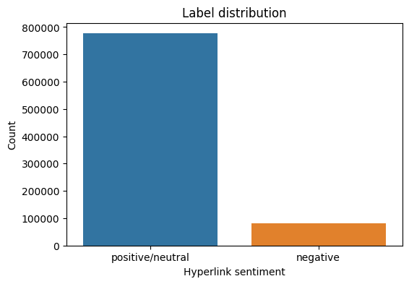
Figure 3.1. Distribution of Reddit hyperlink labels
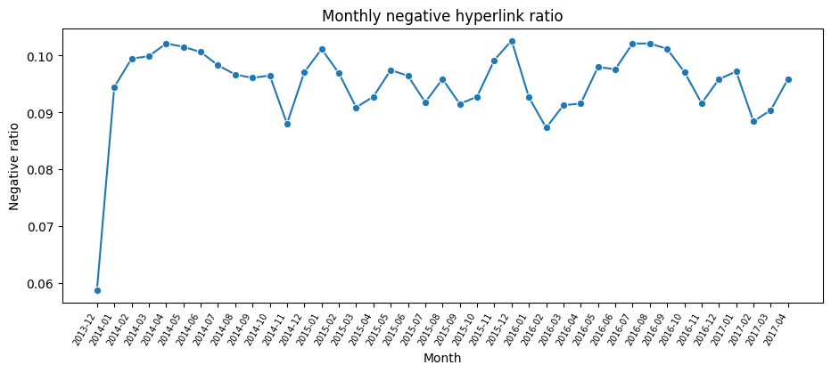
Figure 3.2. Monthly negative-link rate
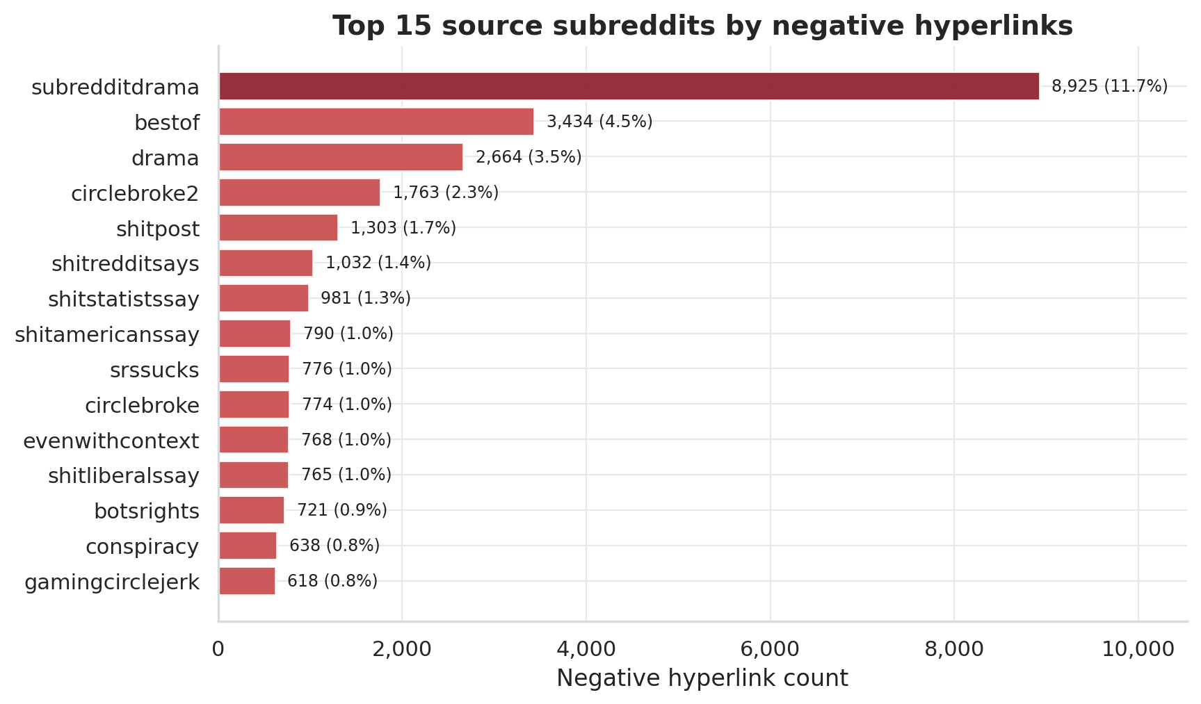
Figure 3.3. Subreddits that frequently act as sources of negative links
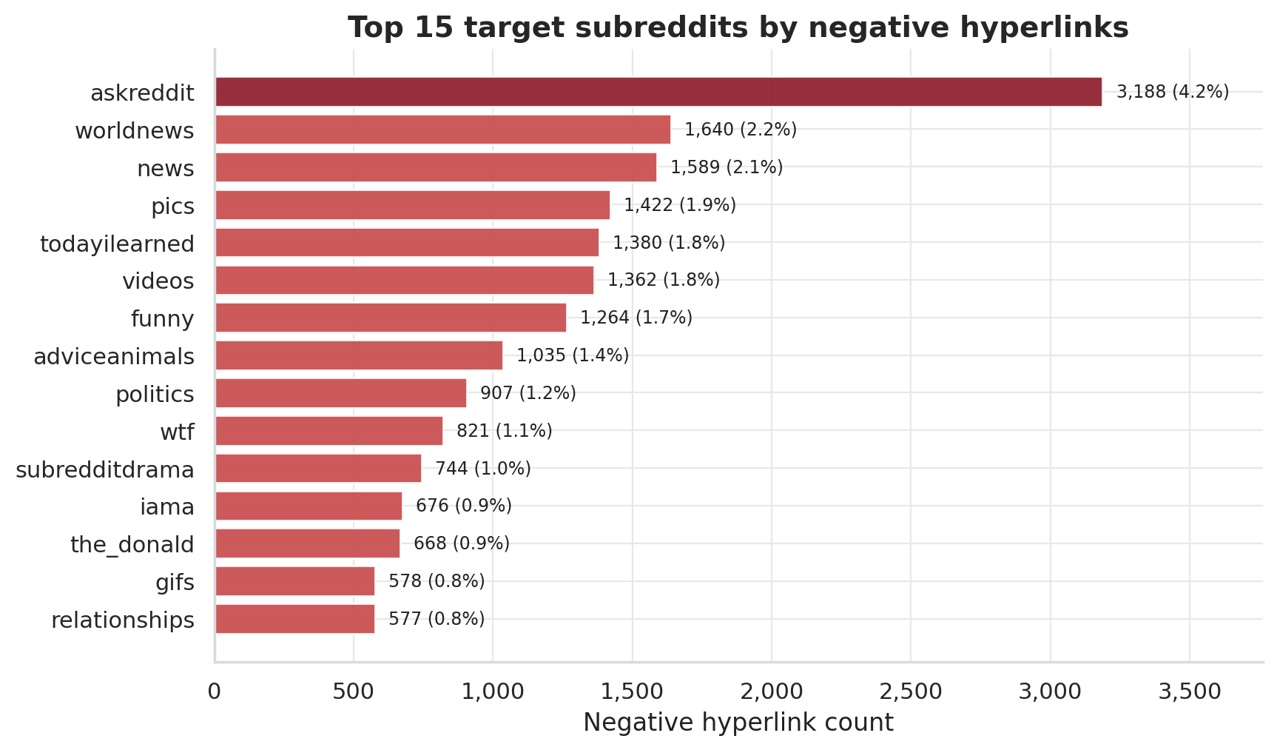
Figure 3.4. Subreddits that frequently act as targets of negative links
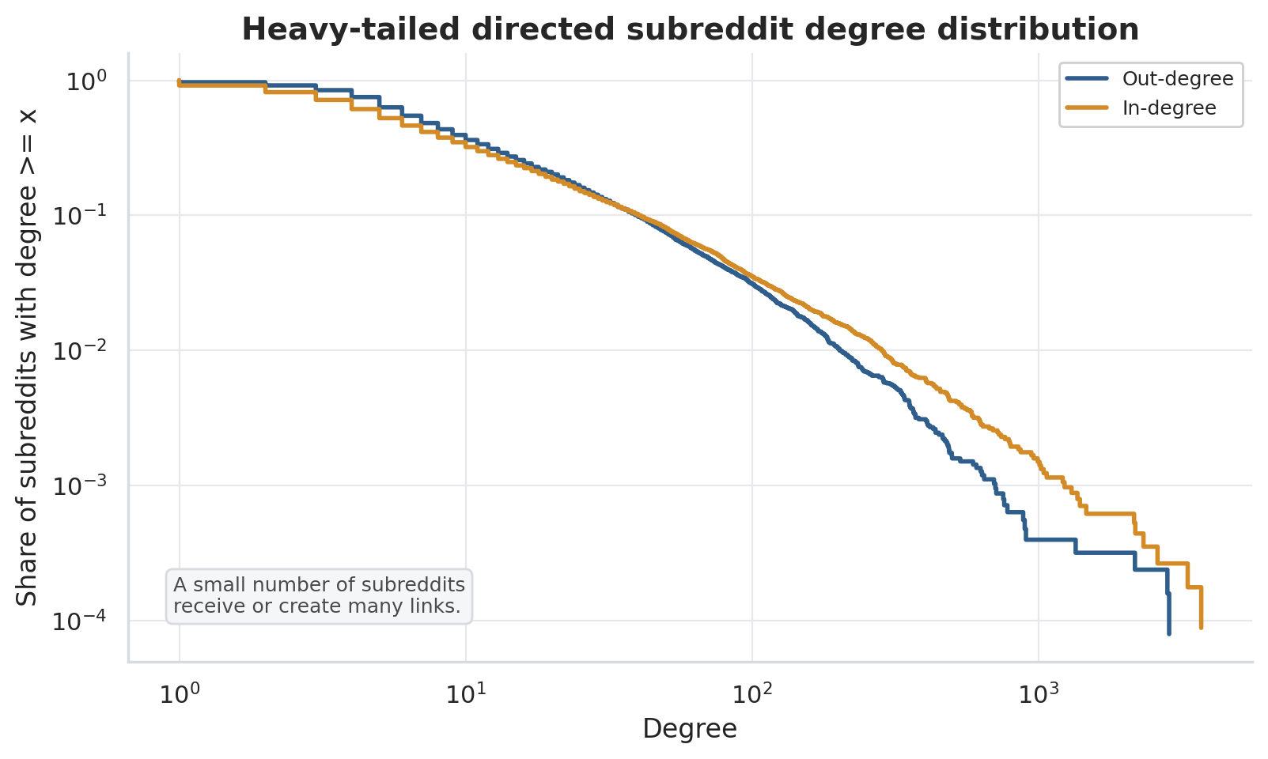
Figure 3.5. Highly skewed degree distribution, a common property of social networks

CHAPTER 4. RESEARCH METHODOLOGY

4.1. Temporal Signed-Network Representation
The data are represented as a directed signed graph. Nodes correspond to subreddits, directed edges correspond to hyperlinks from source_subreddit to target_subreddit, and edge signs are obtained from LINK_SENTIMENT. Because the data are timestamped, the network is not treated as a single static object for modeling. Instead, for each split, feature construction is based on the historical interaction network available before the corresponding cutoff time.

4.2. Temporal Anti-Leakage Design
Temporal anti-leakage is the central principle of the experimental design. For each split, features are computed from the history window, whereas labels are computed from a subsequent future label window. These windows are temporally separated so that label-window outcomes cannot influence the feature matrix. This setup emulates a realistic prediction scenario in which the model has access only to past information at prediction time.
Table 4.1. Temporal train-validation-test split design
Split | History window | Label window | Number of source-target pairs
Train | <= 2015-12-31 | 2016-01-01 to 2016-06-30 | 25,045
Validation | <= 2016-06-30 | 2016-07-01 to 2016-12-31 | 26,450
Test | <= 2016-12-31 | 2017-01-01 to 2017-04-30 | 24,185

4.3. Prediction-Label Construction
For each source-target pair in a split, the pipeline counts negative and non-negative links in the future label window. If future_negative_count exceeds future_positive_count, then negative_label = 1; otherwise, negative_label = 0. This definition focuses on predominantly negative relations, which is more consistent with community-risk warning than merely predicting a single negative hyperlink.

4.4. Pairwise Historical Features
Pairwise historical features describe the previously observed relation between two subreddits. They include total interactions, positive interactions, negative interactions, negative rate, sentiment balance, and related historical variants. This group is a natural baseline because a pair with many prior negative interactions may be more likely to produce negative interactions again in the future.

4.5. Network Features

4.5.1. Degree and Signed-Degree Features
Degree describes the connectivity level of a subreddit in the network. For directed networks, the study distinguishes in-degree from out-degree. For signed networks, it further introduces variables related to negative degree and signed degree to capture tendencies to receive or generate negative links.

4.5.2. PageRank, Betweenness, and Reciprocity
PageRank is used to estimate the importance of a subreddit in the directed hyperlink network (Page et al., 1999). Betweenness captures the extent to which a node lies on important paths between other nodes. Reciprocity describes whether interaction also occurs in the opposite direction between two subreddits. Together, these features help the model identify the structural roles of the source and target in the network.

4.5.3. Clustering and Neighborhood Structure
Clustering and common-neighbor features describe the neighborhood structure of a subreddit pair. Adamic and Adar (2003) show that neighborhood relations can provide signals for link prediction. In signed networks, common neighborhoods can also be combined with edge signs to construct structural-balance patterns.

4.6. Community and Structural-Balance Features
Community features are constructed from detected groups of subreddits in the network. Variables such as the same-community flag, community size ratio, and community negativity gap allow the model to exploit group-level information. Structural-balance features are derived from signed triadic patterns, such as the number of common neighbors that have positive or negative relations with the source and target. This feature group directly connects the model to balance theory in signed networks (Cartwright & Harary, 1956; Leskovec et al., 2010).

4.7. Text-Derived Features
PROPERTIES contains 86 text-derived features provided by the dataset. The pipeline expands this vector into text_property_00 through text_property_85 and then aggregates them by source-target pair within the history window. This feature group is used in the text_only and hybrid models. Because raw text is not processed directly, the study does not assign natural-language semantics to each text_property, but it still evaluates the predictive contribution of the text-derived feature group.

4.8. Models and Baselines
The study compares seven model or baseline groups. Dummy most frequent and dummy prior establish prevalence-level reference points. The historical negative-ratio heuristic provides a domain-informed baseline because it relies on the past negativity of each source-target pair. The machine-learning models include Logistic Regression, Random Forest, XGBoost, and LightGBM. Logistic Regression is retained for interpretability through standardized coefficients, Random Forest provides a non-linear tree-ensemble benchmark (Breiman, 2001), XGBoost offers scalable gradient boosting (Chen & Guestrin, 2016), and LightGBM provides an efficient gradient boosting framework for large tabular data (Ke et al., 2017). The models are implemented in the Python ecosystem using scikit-learn and related libraries (Pedregosa et al., 2011).
Table 4.2. Model and baseline groups
Group | Role in the experiment
Dummy most frequent | Trivial baseline
Dummy prior | Prevalence-based baseline
Historical negative-ratio | Domain baseline based on negative history
Logistic Regression | Interpretable linear model
Random Forest | Tree-ensemble model
XGBoost | Strong gradient boosting for tabular data
LightGBM | Efficient gradient boosting for large-scale data

4.9. Ablation Study Design
The ablation study evaluates the relative contribution of each feature group. The study uses six feature sets:
Table 4.3. Feature sets used in ablation study
Feature set | Meaning
history_only | Uses only pairwise interaction history
text_only | Uses only text-derived features
graph_only | Uses network and structural-balance features
graph_no_balance | Uses network features while excluding structural balance
hybrid | Combines history, network, structural-balance, and text-derived features
hybrid_no_balance | Hybrid feature set excluding structural balance

4.10. Evaluation Metrics
Because negative-dominant relations form the minority class, accuracy is not used as the primary metric. A model that predicts most pairs as non-negative could obtain high accuracy while failing to identify the cases of substantive analytical interest. PR-AUC is therefore used as the primary metric because it is sensitive to ranking quality for the rare positive class. Additional metrics include ROC-AUC, F1, Macro-F1, precision, recall, balanced accuracy, and the confusion matrix.

4.11. Reproducibility
Reproducibility is supported by three artifact groups. First, raw data are not committed to GitHub, but the README explains how to download them from Kaggle and place them under data/raw. Second, scripts/audit_dataset.py validates the schema, labels, timestamps, and PROPERTIES vectors. Third, scripts/run_pipeline.py provides a staged interface with smoke, phase1, phase2, phase3, figures, and all modes. The test suite can be executed with python -m pytest to verify the basic contracts of the parser, temporal split, and metrics outputs.

CHAPTER 5. EXPERIMENTS AND RESULT EVALUATION

5.1. Experimental Setup
The main experiment uses k-core filtering with k = 5 to obtain a denser graph for structural feature extraction. The pipeline constructs feature tables by temporal split, trains models on the training set, selects the decision threshold on the validation set, and evaluates the selected configuration once on the test set. In total, phase3_model_metrics.csv contains 41 model-feature-set rows, covering Logistic Regression, Random Forest, XGBoost, LightGBM, dummy baselines, and the historical negative-ratio heuristic.

5.2. Main Model Results

5.2.1. Best Model by PR-AUC
The best model by test PR-AUC is hybrid Logistic Regression. The main result is reported in Table 5.1.
Table 5.1. Best-performing model
Feature set | Model | Test PR-AUC | Test ROC-AUC | F1 | Macro-F1 | Precision | Recall
hybrid | Logistic Regression | 0.1840 | 0.7569 | 0.2700 | 0.5935 | 0.2050 | 0.3954

This result indicates that combining historical, network, and text-derived features yields the strongest test performance by PR-AUC. The selection of Logistic Regression is also useful analytically because its standardized coefficients make the best-performing model more interpretable than the more complex boosting alternatives.

5.2.2. Baseline Comparison
Table 5.2. Experimental results across models
Feature set | Model | Test PR-AUC | Test ROC-AUC | F1
hybrid | Logistic Regression | 0.1840 | 0.7569 | 0.2700
hybrid_no_balance | Logistic Regression | 0.1837 | 0.7561 | 0.2673
graph_only | Logistic Regression | 0.1812 | 0.7508 | 0.2624
hybrid | LightGBM | 0.1792 | 0.7626 | 0.2560
hybrid | XGBoost | 0.1755 | 0.7532 | 0.2348
graph_no_balance | Random Forest | 0.1730 | 0.7481 | 0.2441
history_only | Logistic Regression | 0.1424 | 0.6911 | 0.2343
text_only | Logistic Regression | 0.1398 | 0.7118 | 0.2202
graph_only | Historical negative ratio | 0.1237 | 0.6328 | 0.2327
hybrid | Dummy prior | 0.0698 | 0.5000 | 0.1304

Table 5.2 shows that models using network or hybrid features outperform the dummy baselines and the historical negative-ratio heuristic. This pattern suggests that the strongest models do not merely reproduce prior negative rates; they also exploit structural information about source and target communities, as well as complementary text-derived attributes.

5.2.3. Interpretation under Class Imbalance
The test set has a negative-dominant relation rate of approximately 0.07. In this context, a PR-AUC of 0.1840 should be interpreted relative to the rare positive-class prevalence rather than judged only by its absolute value. Compared with the dummy prior PR-AUC of 0.0698, the achieved value is approximately 2.6 times higher. Because PR-AUC emphasizes ranking performance for the rare positive class, this improvement is meaningful for a screening-oriented analytical task.

5.3. Baseline and Ablation Analysis
Graph-only Logistic Regression achieves a PR-AUC of 0.1812, which is close to the hybrid Logistic Regression result. This suggests that interaction history and signed-network structure constitute the strongest signal family. Text-only Logistic Regression reaches a PR-AUC of 0.1398, outperforming the dummy prior but remaining below graph-only performance. Thus, the text-derived PROPERTIES vector contains useful predictive information, but it is not sufficiently strong as a standalone representation. Its value is most evident when combined with network and history features in the hybrid feature set.
The comparison between hybrid and hybrid_no_balance indicates that structural-balance features provide only a small gain. The PR-AUC difference between 0.1840 and 0.1837 is modest, so structural balance should not be presented as the primary driver of predictive performance. Nevertheless, this feature group remains valuable for interpretation because it links the empirical model to signed-network theory and local triadic structure.

5.4. Threshold, Precision, and Recall Analysis
The threshold is selected on the validation set to optimize F1. For hybrid Logistic Regression, the threshold applied to the test set is 0.72. The confusion matrix of the best model is as follows:
Table 5.3. Confusion matrix values of the best-performing model
TN | FP | FN | TP
19,911 | 2,587 | 1,020 | 667

The model identifies 667 true-positive cases, corresponding to a recall of 0.3954. Precision reaches 0.2050, reflecting the difficulty of identifying rare negative-dominant pairs. In a community-risk analysis setting, false positives would increase review cost, whereas false negatives would leave potentially negative community pairs unflagged. The decision threshold should therefore be selected according to the intended operational tradeoff between review burden and missed-risk tolerance.
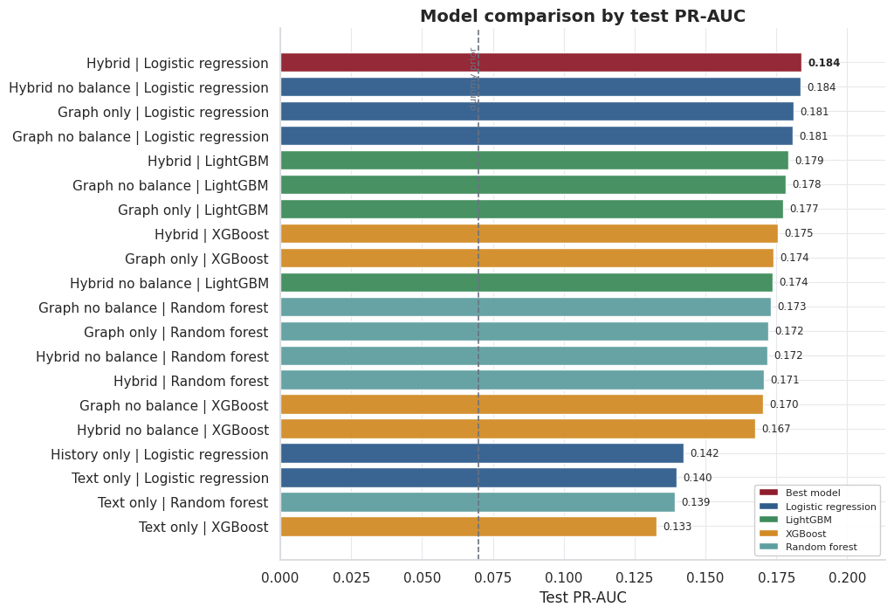
Figure 5.1. PR-AUC comparison by model
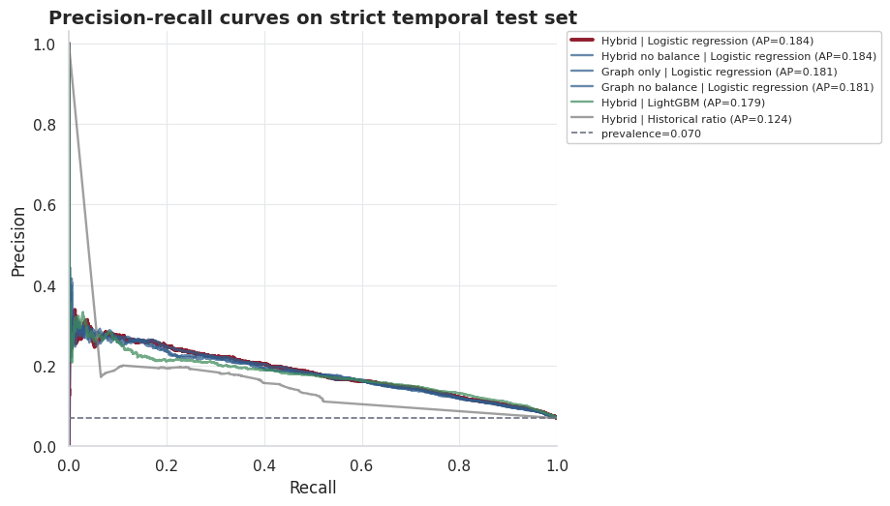
Figure 5.2. Precision-Recall curve
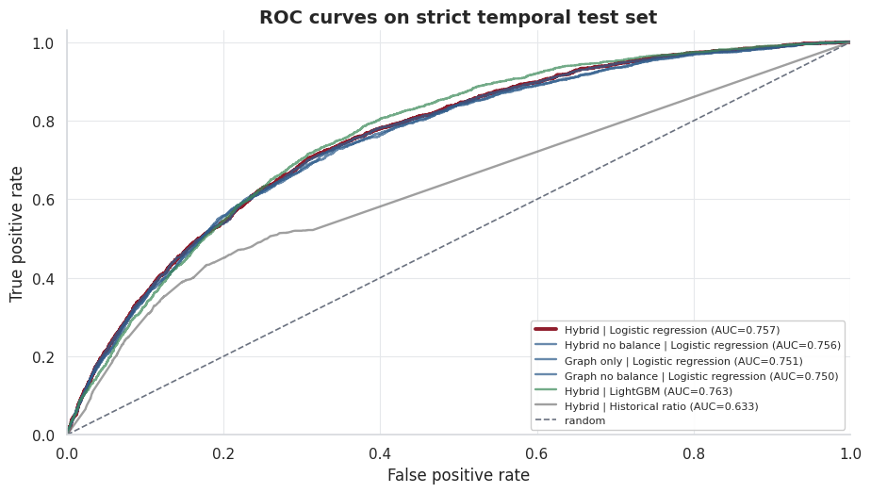
Figure 5.3. ROC curve
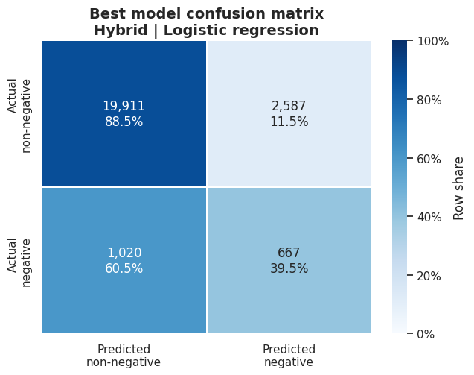
Figure 5.4. Confusion matrix of the best-performing model
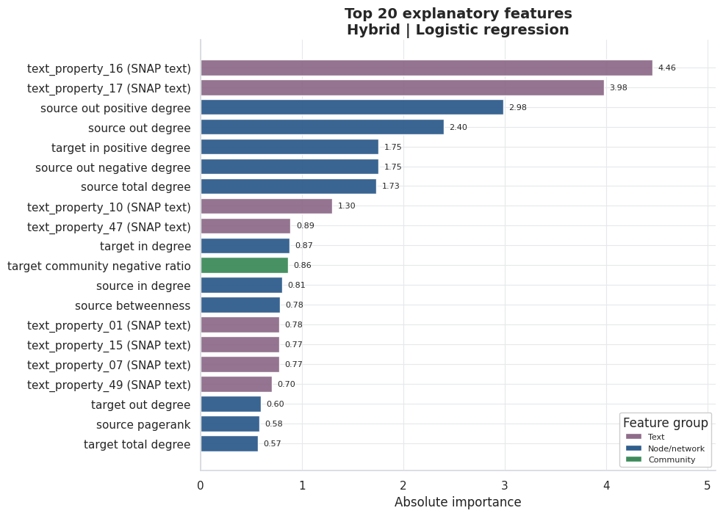
Figure 5.5. Top feature importance

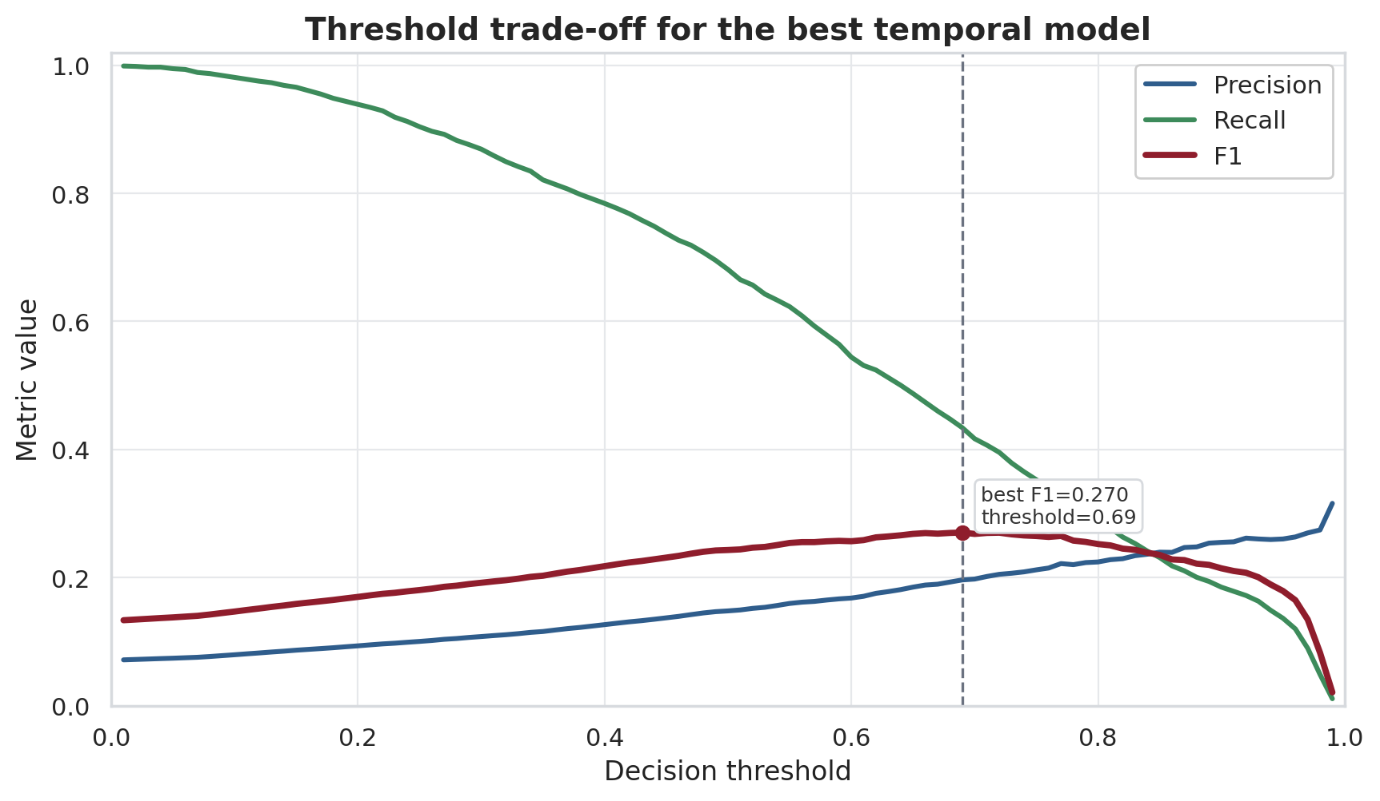
Figure 5.6. Tradeoff among precision, recall, and F1 across thresholds

5.5. K-Core Robustness Check

5.5.1. Robustness-Probe Design
To examine whether the conclusions depend too strongly on the k = 5 graph-density choice, the study adds a sampled robustness probe using 100,000 interactions sampled evenly over time from the original data. The probe compares k = 3, k = 5, and k = 10 under two modes: global_k_core and history_safe_k_core. In history_safe_k_core mode, the retained node set is derived from training-history structure and then applied to subsequent windows, reducing concerns that future graph structure determines the evaluated cohort.

5.5.2. Robustness Results
Table 5.4. K-core robustness results
Filtering mode | k | Test PR-AUC | Test F1 | Test recall
global k-core | 3 | 0.1382 | 0.2128 | 0.3952
global k-core | 5 | 0.1473 | 0.2205 | 0.4093
global k-core | 10 | 0.1391 | 0.2185 | 0.3873
history-safe k-core | 3 | 0.1477 | 0.2231 | 0.4258
history-safe k-core | 5 | 0.1561 | 0.2269 | 0.4286
history-safe k-core | 10 | 0.1594 | 0.2441 | 0.4351

The results show that historical signal persists across multiple k-core levels. PR-AUC does not collapse when k changes, and the history-safe mode maintains relatively stable performance. These findings reduce, although do not eliminate, the risk that the main conclusion is merely an artifact of a single k-core selection.

5.5.3. Limitations of the Robustness Probe
The robustness probe has two important limitations. First, it uses a sample of 100,000 interactions rather than the full 858,488 interactions. Second, it uses a lighter history-only Logistic Regression model rather than the full hybrid feature set. Therefore, the probe should be interpreted as supporting evidence about the stability of the k-core filtering choice, not as a substitute for a full-scale hybrid sensitivity analysis.
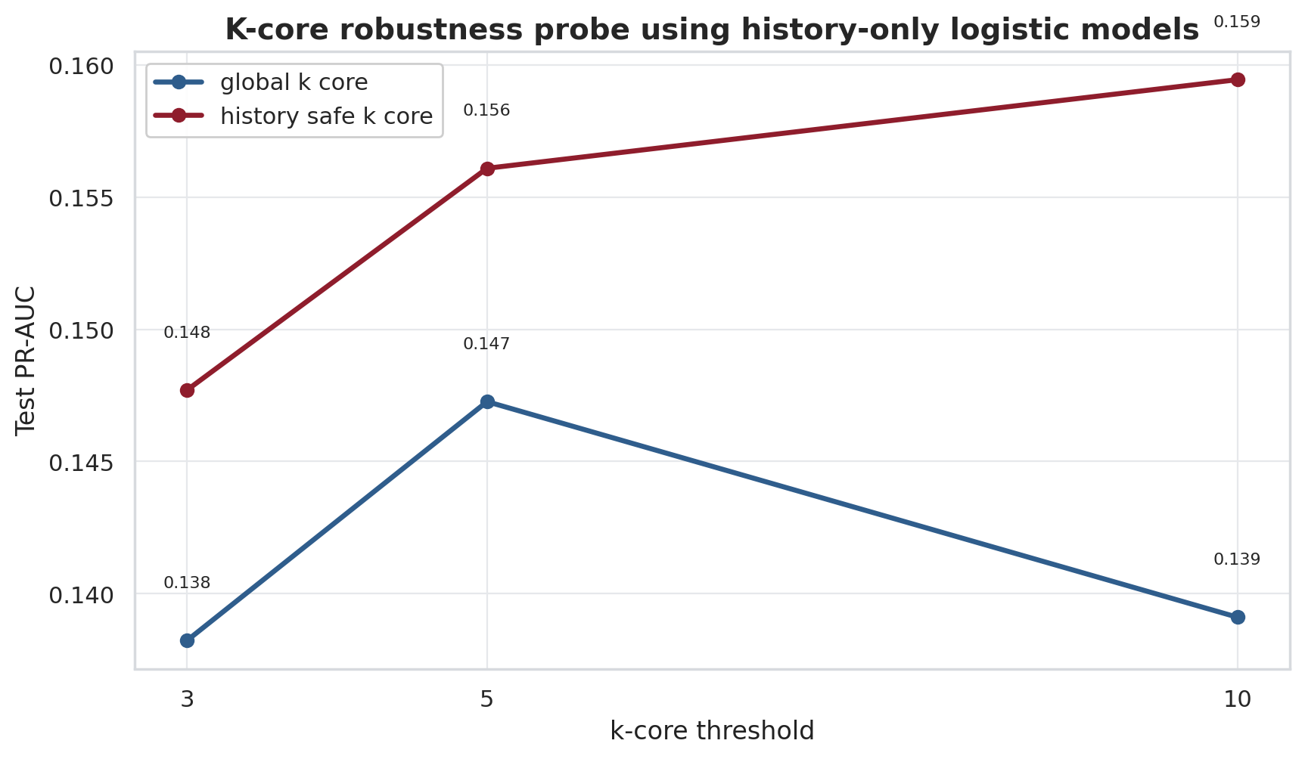
Figure 5.7. PR-AUC of the history-only model under different k-core configurations

5.6. Error Analysis

5.6.1. True positives
True-positive cases are usually source-target pairs with a clear prior record of negative interaction or with network features that indicate elevated relational risk. In the exported error-analysis artifacts, this group often has high prior negative ratios, many past negative links, or enough history_interactions for the model to identify a persistent pattern. This suggests that the model is not relying on a single feature in isolation; rather, it combines pairwise history with the structural positions of the source and target communities. Substantively, true positives provide the strongest local evidence for the central assumption of the study: past negative relations and signed-network context can provide useful signals about future negative-dominant relations.

5.6.2. False positives
False positives often occur when a subreddit pair has a high historical negative rate but does not become negative-dominant in the test window. These cases show that historical negativity is an important signal, but it is not sufficient to conclude that a future relation will necessarily be negative. Possible explanations include contextual shifts between communities, small future interaction volumes, or a small number of positive or neutral future links that change the pair-level label. For an early-warning use case, false positives should therefore be interpreted as review cost rather than as evidence that the model has established an actual conflict.

5.6.3. False negatives
False negatives often reflect pairs whose future negativity emerges without strong historical evidence or with only sparse prior interactions. In these cases, the model lacks enough past evidence to anticipate a negative-dominant relation, especially when negativity is triggered by new events, shifts in discussion topics, or unusual interactions outside the observed history window. This group of errors exposes a natural limitation of models based mainly on pair history and graph features. Reducing false negatives would likely require richer raw-text modeling, user-level behavior, moderation signals, or event-level temporal features beyond the current representation.

5.7. Model Interpretation
Because the best-performing model is Logistic Regression on the hybrid feature set, it can be interpreted through standardized coefficients and feature importance. The most influential features include selected text properties, source out-degree, source signed degree, target in-degree, source negative degree, PageRank, betweenness, and community-level negativity. This pattern is substantively plausible: the likelihood of a future negative-dominant relation depends on prior pair interaction, the structural roles of the source and target, and the surrounding community environment.

5.8. Network and Community Visualization
The visualizations in this section connect model performance with the observable network structure. Figure 5.8 illustrates a backbone of negative links to show that the task is not merely a tabular classification problem, but also a problem of community position and inter-community relations. Figure 5.9 shows that negative-link rates vary across communities, while Figure 5.10 shows that negativity is unevenly distributed across source-target community pairs. Together, these visualizations support the research question about which communities act as frequent sources or targets of negative links and reinforce the rationale for including network and community-level features in the model.
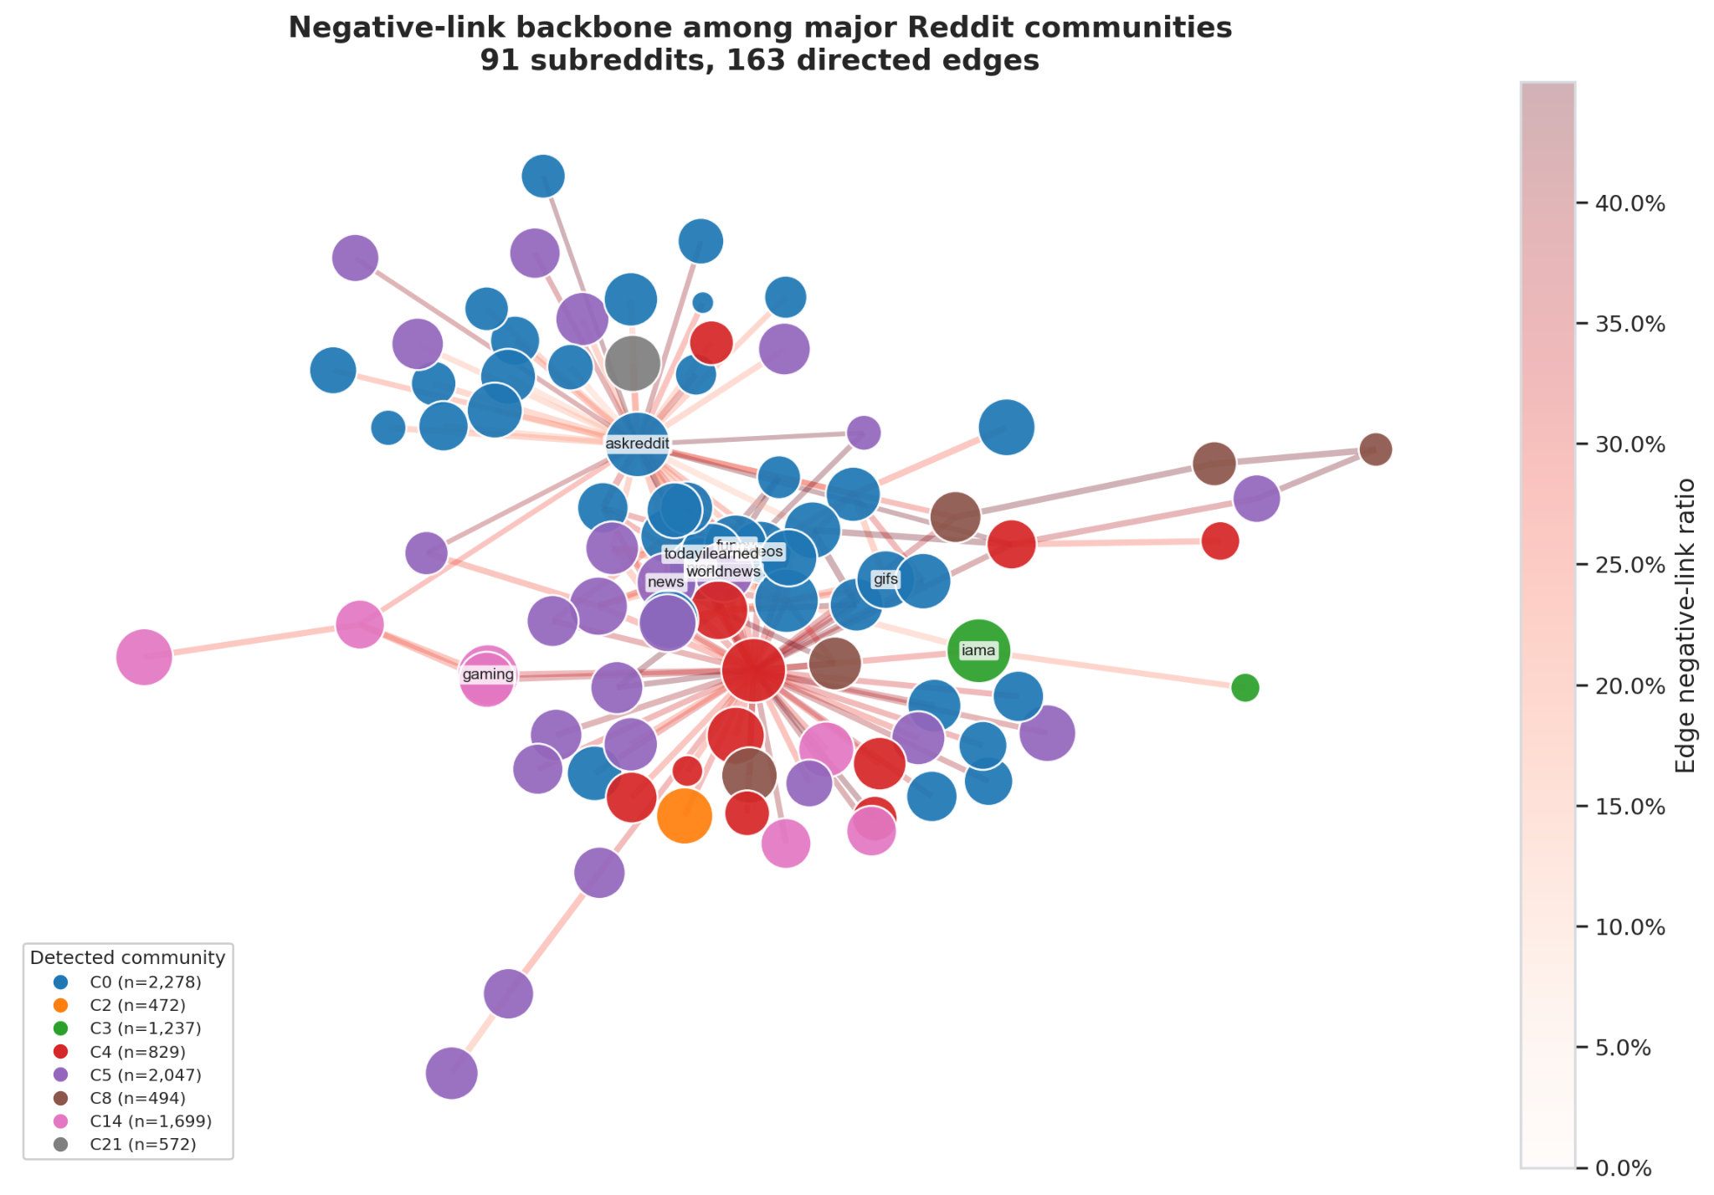
Figure 5.8. Visualization of a backbone of negative links among communities
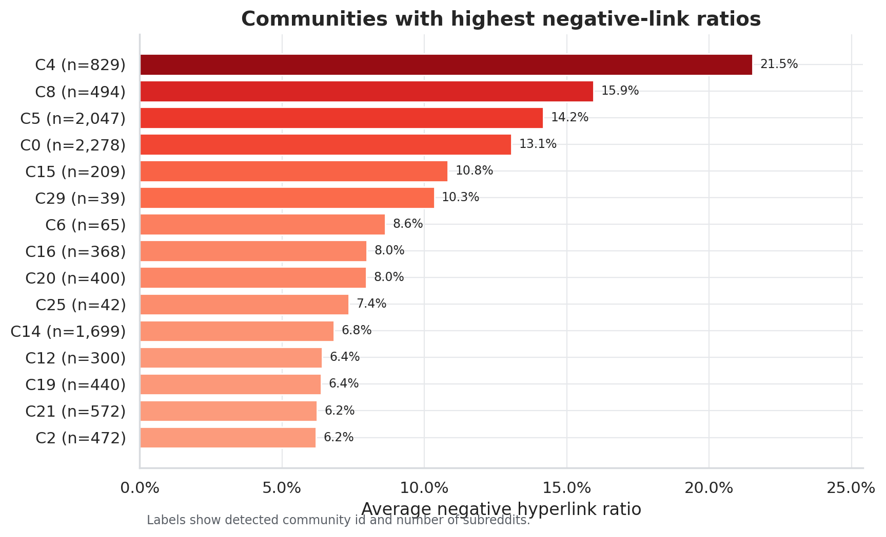
Figure 5.9. Variation in negative-link rates across communities
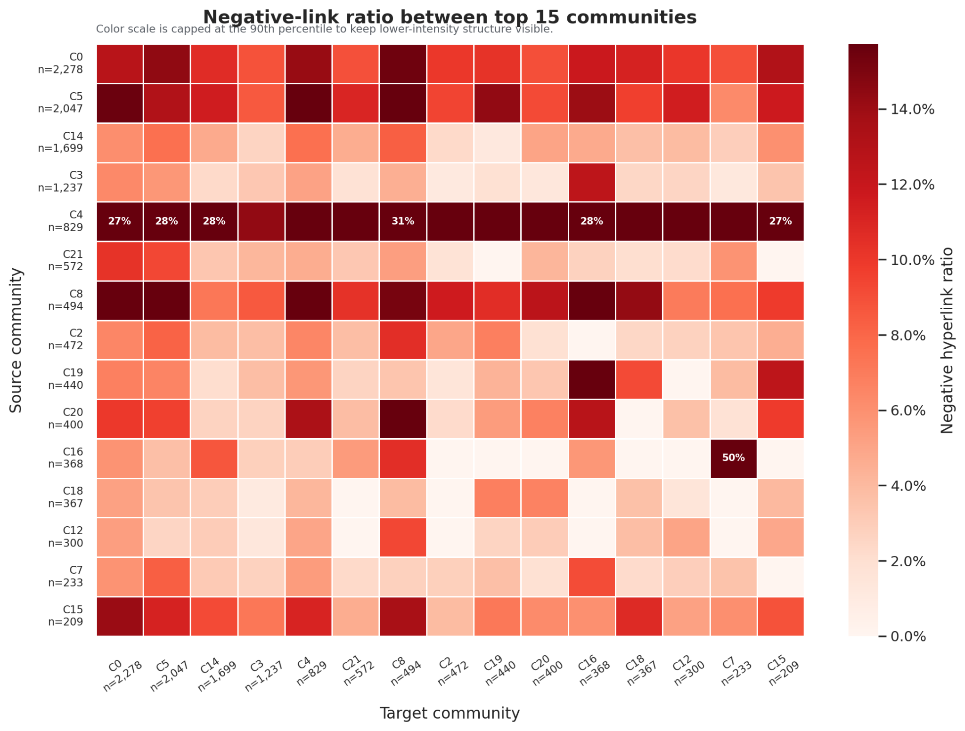
Figure 5.10. Negative-link rate variation by source-target community pair

5.9. Discussion of Results
The experimental results support three main conclusions. First, historical and signed-network structural features provide the most stable signal family. Second, text-derived features are useful when combined with graph features, but they are weaker as standalone predictors. Third, structural-balance features have greater interpretive value than direct performance-gain value under the strict temporal setup used in this study.
Theoretically, these findings are consistent with the temporal signed-network framework developed in Chapter 2. Pairwise interaction history reflects persistence in source-target relations; centrality and community features capture the positions of subreddits in the broader network; and structural-balance features connect prediction to signed local-neighborhood patterns. The small PR-AUC gain from structural-balance features is also informative: in this strict temporal setting, their main value appears to be interpretive rather than a large improvement in absolute predictive performance.
The practical value of this study lies in its ability to generate analytical warning signals that support community-level investigation. The model should not be used to assert that conflict has occurred; rather, it can help prioritize community pairs that warrant closer qualitative examination. This interpretation is consistent with the proxy nature of LINK_SENTIMENT and avoids turning the model into an automatic, context-free decision system.

CHAPTER 6. CONCLUSION

6.1. Main Conclusions
This study developed a reproducible pipeline for predicting negative-dominant relations between subreddits using temporal signed-network features. The best result is achieved by hybrid Logistic Regression, with PR-AUC = 0.1840, ROC-AUC = 0.7569, and F1 = 0.2700. Relative to the dummy prior and the historical negative-ratio heuristic, this model demonstrates the value of combining interaction history, network structure, and text-derived features.

6.2. Limitations and Threats to Validity
The first limitation concerns construct validity. LINK_SENTIMENT is a proxy label for negative stance in hyperlink-mediated interaction, not direct evidence of harassment, raids, or real-world inter-community conflict. Therefore, model outputs should be interpreted as analytical warning signals rather than as final sociological conclusions.
The second limitation concerns temporal validity. The data cover the 2013-2017 period, while Reddit, user behavior, and moderation practices may have changed substantially since then. The model should therefore be re-evaluated on more recent data before its findings are generalized to the current platform environment.
The third limitation concerns sampling and graph construction. K-core filtering reduces sparsity and stabilizes network features, but it also concentrates the analysis on denser parts of the graph. The robustness probe partially addresses this concern, but it is sampled and history-only, so it does not replace a full-scale hybrid sensitivity analysis.
Finally, the current formulation focuses on source-target pairs with observed history and does not fully address entirely cold-start pairs. This limitation is important for any future early-warning system, because previously unseen relations may emerge without enough historical evidence for the current feature design.

6.3. Future Directions
Promising future directions include signed graph embeddings, temporal graph neural networks, raw-text modeling, SHAP or GNNExplainer-based interpretation, robustness testing under label noise, and evaluation on more recent social media data. In addition, the task could be extended from pair-level prediction to event-level or community-level early warning if user-behavior traces, moderation events, or richer temporal context become available.

6.4. Recommendations for Interpretation
The results of this study should be used as analytical support signals, not as automatic evidence that two communities conflict. In practical settings, model outputs should be combined with qualitative analysis, content inspection, moderator judgment, and the relevant social context before any substantive conclusion is drawn.

REFERENCES
- Adamic, L. A., & Adar, E. (2003). Friends and neighbors on the Web. Social Networks, 25(3), 211-230. https://doi.org/10.1016/S0378-8733(03)00009-1
- Blondel, V. D., Guillaume, J.-L., Lambiotte, R., & Lefebvre, E. (2008). Fast unfolding of communities in large networks. Journal of Statistical Mechanics: Theory and Experiment, 2008(10), P10008. https://doi.org/10.1088/1742-5468/2008/10/P10008
- Breiman, L. (2001). Random forests. Machine Learning, 45, 5-32. https://doi.org/10.1023/A:1010933404324
- Cartwright, D., & Harary, F. (1956). Structural balance: A generalization of Heider's theory. Psychological Review, 63(5), 277-293. https://doi.org/10.1037/h0046049
- Chen, T., & Guestrin, C. (2016). XGBoost: A scalable tree boosting system. In Proceedings of the 22nd ACM SIGKDD International Conference on Knowledge Discovery and Data Mining (pp. 785-794). Association for Computing Machinery. https://doi.org/10.1145/2939672.2939785
- Fortunato, S. (2010). Community detection in graphs. Physics Reports, 486(3-5), 75-174. https://doi.org/10.1016/j.physrep.2009.11.002
- Freeman, L. C. (1978). Centrality in social networks: Conceptual clarification. Social Networks, 1(3), 215-239. https://doi.org/10.1016/0378-8733(78)90021-7
- Heider, F. (1946). Attitudes and cognitive organization. The Journal of Psychology, 21(1), 107-112. https://doi.org/10.1080/00223980.1946.9917275
- Holme, P., & Saramäki, J. (2012). Temporal networks. Physics Reports, 519(3), 97-125. https://doi.org/10.1016/j.physrep.2012.03.001
- Ke, G., Meng, Q., Finley, T., Wang, T., Chen, W., Ma, W., Ye, Q., & Liu, T.-Y. (2017). LightGBM: A highly efficient gradient boosting decision tree. Advances in Neural Information Processing Systems, 30. https://proceedings.neurips.cc/paper_files/paper/2017/hash/6449f44a102fde848669bdd9eb6b76fa-Abstract.html
- Kumar, S., Cheng, J., & Leskovec, J. (2017). Antisocial behavior on the Web: Characterization and detection. In Proceedings of the 26th International Conference on World Wide Web Companion (pp. 947-950). International World Wide Web Conferences Steering Committee. https://doi.org/10.1145/3041021.3051106
- Kumar, S., Hamilton, W. L., Leskovec, J., & Jurafsky, D. (2018). Community interaction and conflict on the Web. In Proceedings of the 2018 World Wide Web Conference (pp. 933-943). International World Wide Web Conferences Steering Committee. https://doi.org/10.1145/3178876.3186141
- Leskovec, J., Huttenlocher, D., & Kleinberg, J. (2010). Signed networks in social media. In Proceedings of the SIGCHI Conference on Human Factors in Computing Systems (pp. 1361-1370). Association for Computing Machinery. https://doi.org/10.1145/1753326.1753532
- Liben-Nowell, D., & Kleinberg, J. (2007). The link-prediction problem for social networks. Journal of the American Society for Information Science and Technology, 58(7), 1019-1031. https://doi.org/10.1002/asi.20591
- Page, L., Brin, S., Motwani, R., & Winograd, T. (1999). The PageRank citation ranking: Bringing order to the Web. Stanford InfoLab. http://ilpubs.stanford.edu:8090/422/
- Pedregosa, F., Varoquaux, G., Gramfort, A., Michel, V., Thirion, B., Grisel, O., Blondel, M., Prettenhofer, P., Weiss, R., Dubourg, V., Vanderplas, J., Passos, A., Cournapeau, D., Brucher, M., Perrot, M., & Duchesnay, E. (2011). Scikit-learn: Machine learning in Python. Journal of Machine Learning Research, 12, 2825-2830. http://jmlr.org/papers/v12/pedregosa11a.html
- Saito, T., & Rehmsmeier, M. (2015). The precision-recall plot is more informative than the ROC plot when evaluating binary classifiers on imbalanced datasets. PLOS ONE, 10(3), Article e0118432. https://doi.org/10.1371/journal.pone.0118432
- Stanford Network Analysis Project. (n.d.). Reddit hyperlink network. Stanford University. Retrieved June 1, 2026, from https://snap.stanford.edu/data/soc-RedditHyperlinks.html
- Wolfram77. (n.d.). Signed graphs [Data set]. Kaggle. Retrieved June 1, 2026, from https://www.kaggle.com/datasets/wolfram77/graphs-signed

APPENDICES
Appendix A. Pipeline Reproduction Commands
- Link GitHub:
https://github.com/Tommyhuy1705/Explainable_Signed_Link_Prediction_for_Reddit_Inter-Community_Conflict_Warning.git
- Reproducibility commands:
python scripts/audit_dataset.py --raw-dir data/raw --json-out data/processed/dataset_audit.json
python scripts/run_pipeline.py --stage smoke
python scripts/run_pipeline.py --stage all --k-core 5
python scripts/create_presentation.py; python -m pytest.

Appendix B. Dataset Audit Summary
The latest audit confirms that the combined dataset contains 858,488 rows, 82,210 negative links, and a negative-link rate of 9.58%. Both raw files contain all required columns, valid timestamps, valid labels, and exactly 86 PROPERTIES values per row.

Appendix C. Output Artifact List
The main artifacts include:
- data/processed/dataset_audit.json
- data/processed/phase3/phase3_model_metrics.csv
- data/processed/phase3/phase3_feature_importance.csv
- data/processed/phase3/error_analysis_cases.csv
- data/processed/phase3/robustness_metrics.csv

Appendix D. Task Allocation Table
Member | Tasks | Progress
Tran Viet Gia Huy | - Network Construction and Feature Engineering  - Build the signed directed MultiDiGraph using NetworkX  - Extract node, pair, community, structural balance, and text-based features  - Analyze network structure and community-level negative patterns  - Write report  - Slides | 100%
Nguyen Trong Huong | - Dashboard, Pipeline, and Final Reporting  - Build the Streamlit dashboard with five interactive tabs  - Implement Plotly charts and data access layer for dashboard visualization  - Maintain pipeline scripts, unit tests, and presentation generation script  - Write report  - Slides | 100%
Nguyen Minh Nhut | - Modeling, Evaluation, and Robustness Analysis  - Implement anti-leakage temporal split for model evaluation  - Train baseline models, Logistic Regression, Random Forest, XGBoost, and LightGBM  - Perform ablation study, threshold tuning, robustness analysis, and error analysis  - Write report  - Slides | 100%
To Xuan Dong | - Data Engineering and Exploratory Data Analysis  - Load, clean, and merge Reddit hyperlink datasets  - Perform k-core filtering and dataset audit  - Analyze label distribution, temporal trends, and top negative sources/targets  - Write report  - Slides | 100%

